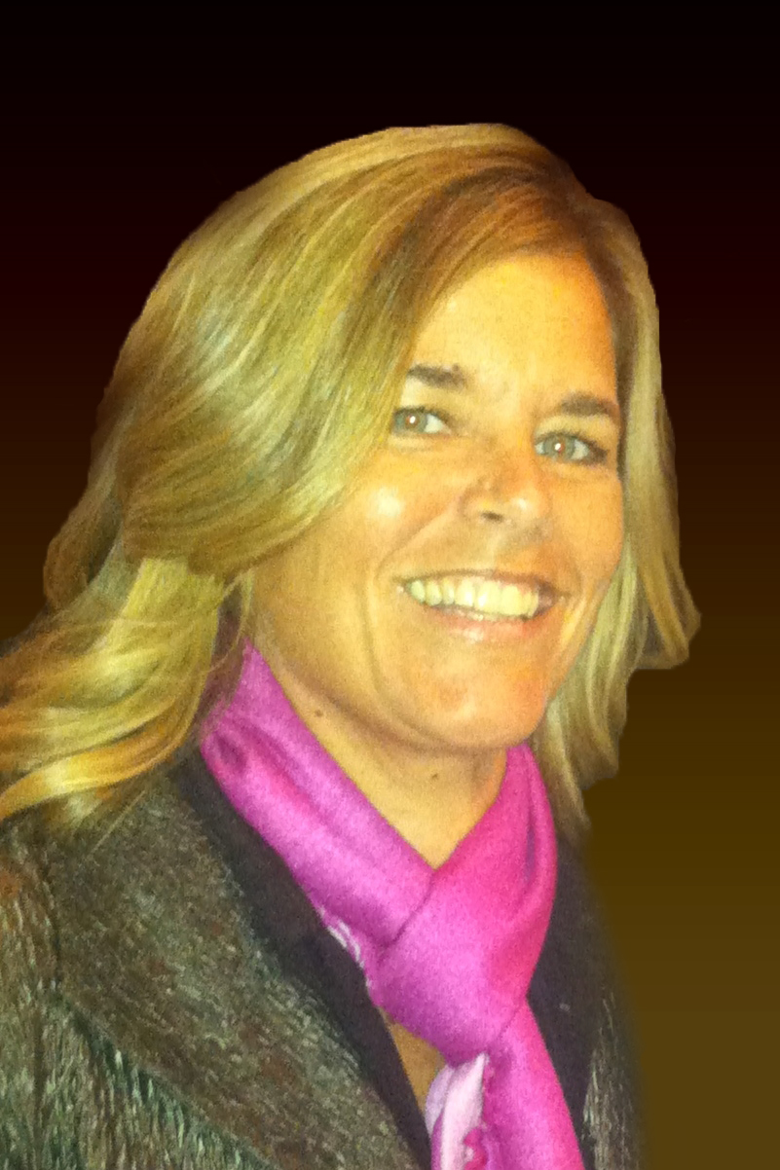
Jamie Watson

Professional Profile

Sports broadcaster, Jamie Watson, is the only female play by play broadcaster who has started in 3 Final Fours and was a 5-year D1 head coach at UMBC. Her passion is PxP, calling games for the NWSL, Concacaf and ESPN. In 2024, Jamie called a total of 90 games. Jamie has worked 9 years with Loyola University of Maryland Men’s and Women’s Soccer teams & Women’s Basketball. Jamie is currently PxP for Loyola WBB. She has called PxP games for the WORLD LACROSSE Women’s World Championships on ESPN and MWLacrosse at Mount St. Mary’s University for 5 years. Jamie completed three GALvanize sports broadcasting bootcamps led by Fox Sports reporter, Laura Okmin. In these bootcamps, Jamie worked with the NFL San Diego Chargers, WNBA LA Sparks, and Olympic gold medalist, Picabo Street. In addition, Jamie has over 650 hours of live radio broadcasts under her belt and the reputation of being one of the best all-round sports broadcasters.

Professional Experience

CONCACAF Nations League 2024

NWSL Summer Cup 2024

USWNT 4 Friendlies 2024

USMNT 4 Friendlies 2024

SHE BELIEVES CUP 2024

CONCACAF – Women’s Gold Cup 2024

CONCACAF – U17, CNL, R2WGC 2023

NWSL – National 2023

NWSL – Angel City Football Club 2022

WORLD LACROSSE Women’s World Championships – ESPN 2022

Patriot League WBB/WSoc - ESPN 2022

Patriot League WSoc Championships – Stadium Television 2019
Analyst

NJCAA Championships WLax – NJCAATV 2019
Play by Play

Northeast Conference WLax Championships – ESPN3 2019
Analyst

Mount St. Mary’s University 2015-2021
Play by Play MWLax

Loyola University Maryland 2015-present
Analyst MWSoc & WBB
Play by Play WSoc & WBB

GALvanize Broadcast Bootcamps with Laura Okmin 2015

Fox Sports Q1370 AM & 99.9FM 2008-2014
Producer and Host “Tee Off with Jamie Watson” -Baltimore, MD
Local sports radio talk show host on Sunday mornings 10-11am. Jamie produced this show where the station gave her space to develop the strategy and direction. Jamie interviewed local and national sports celebrities, balancing this with 5-8 listener calls, keeping the show vibrant and interesting.
- Covered all sports including NFL, MLB, Fantasy Football, Golf, Tennis, Olympics, World Cup, NCAA Lacrosse, Soccer, Field Hockey & Basketball
- Interviewed professional golfers, attended press conferences, obtained sound bites, and covered PGA, LPGA, & USGA events.
- Interviews included: Adam Jones, Chris Davis, Jim Palmer, Gary Player, Tom Watson, John Feinstein, Earl Woods, Barney Adams, Betsy Rawls, Meg Mallon, and Annika Sorenstam.

University of Maryland – Baltimore County 1990-1995
Head Women’s Soccer Coach/Academic Advisor -Catonsville, MD
Division I NCAA Head Coach responsible for operating budget and scholarship monies, recruiting, fundraising, scheduling, safety of players, and community service projects.
- Big South Coach of the Year 1994, Mid-Atlantic Regional Ranking, 1994
- Assistant Academic Advisor responsible for advising 1500 student-athletes on their academic futures

Professional Memberships
- The Ladies Professional Golf Association Teaching and Club Professional Division
Passed playing abilities test and officially accepted to the LPGA T&CP Division on September 27, 1996
- National Soccer Coaches Association of America
Received National Soccer Coaches Association of America license August 1989

Education
BS Exercise Physiology, University of Massachusetts, Amherst MA
- Four-year starter on Div. I Soccer team; captain senior year; ranked #1, undefeated (15-0)
- Competed in three straight NCAA Final Fours
- Captain senior year, ranked #1 in the nation and defeated UNC 2-0 .

High School Diploma, Dulaney High School, Timonium MD
- Earned 9 varsity letters in 6 different sports.
- First girl to play on boys varsity soccer team.
- Inducted to Dulaney High School Athletic Hall of Fame on November 5, 2012

Additional Information
- Flexible to travel as necessary
- Live nearby metro airport

